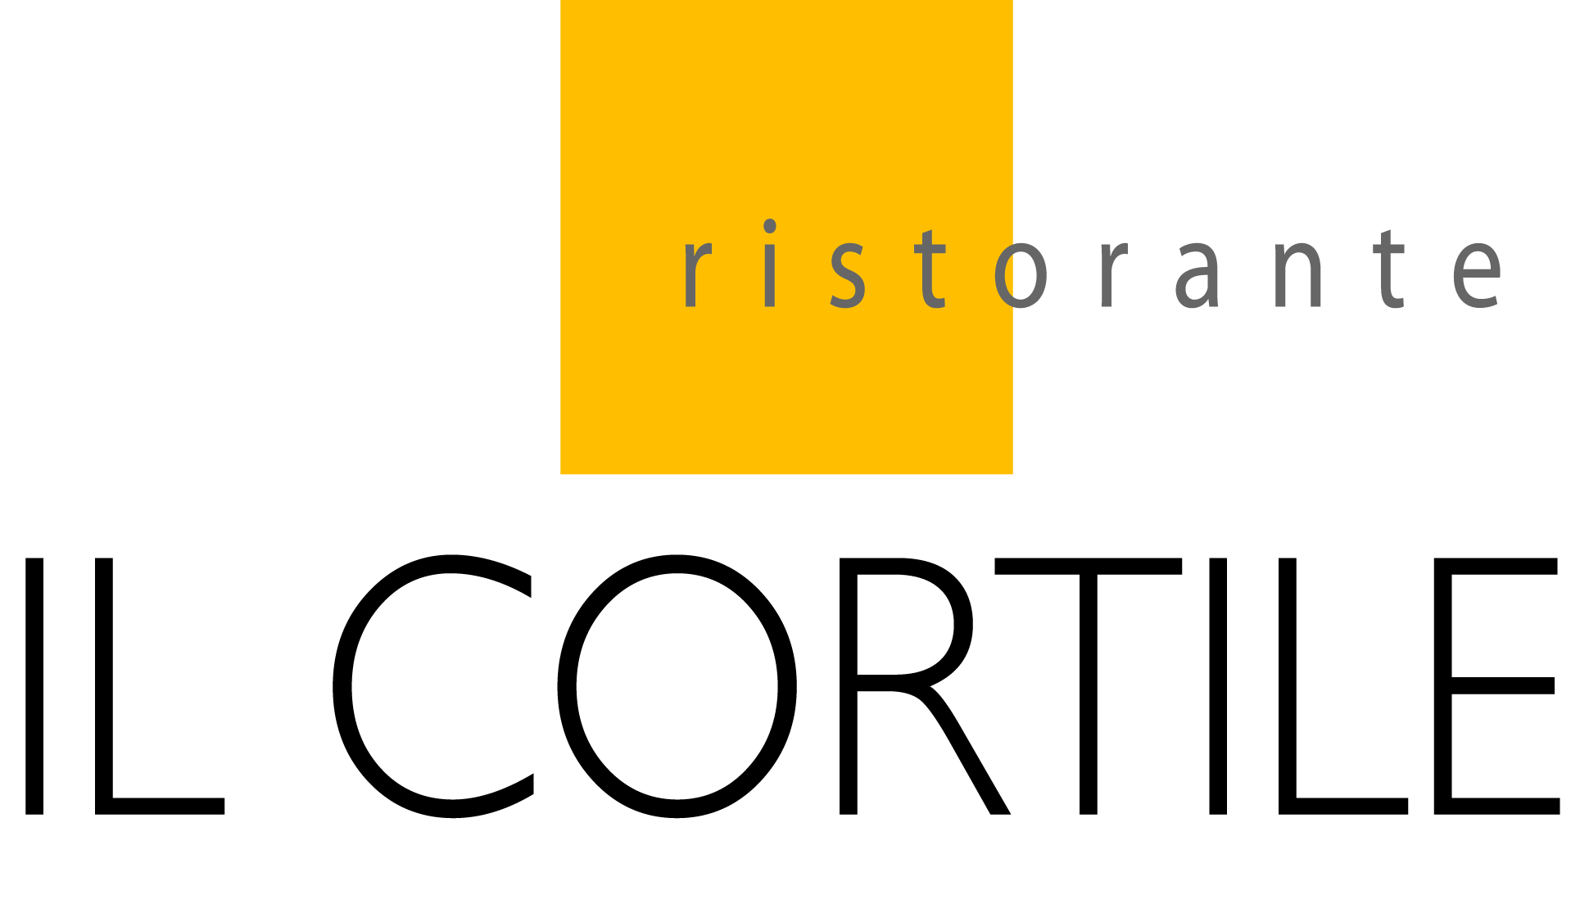

Chef Santos
White Truffle Tasting Menu
$250.00

ANTIPASTA

Uovo~ Mighty Cap blue oyster mushrooms with a poached egg over fontina fonduta and shaved white truffles

PRIMI

Tagliolini all’ aragosta ~ house made tagliolini with lobster ragu and shaved white truffles

PRIMI

Agnolotti tartufo~ sweet corn agnolotti in a black truffle butter sauce and shaved white truffles

SECONDI

Bistecca tagliata~ sliced rib eye with a pecorino sauce and shaved white truffles

DOLCI

Optional wine pairing ~ $75

